Woolcock Institute of Medical Research
Stroop
Technical Specifications for Research Tools

5/11/2018

Stroop

The Stroop test assesses the inhibition of dominant responses, and reflects the “higher-order” executive functions. It is a two-part test (Stroop-Text and Stroop-Colour) assessing reaction time to colours and words displayed and gauges cognitive interference which is impacted by the presentation of simultaneous conflicting information. Words (red, green, or blue) and three different coloured squares (red, green, or blue) were displayed on the computer screen. Participants were required to click on the coloured square that matched either the MEANING (Stroop-Text) or the COLOUR (Stroop-Colour) of the word presented. Each part of the test was 45 seconds in duration and involved multiple trials. Variables evaluated were percentage of correct total responses; and average response latency.
Variable Code | Variable
SPC | Percentage of correct responses (SCORR/STOTALx100)
SPRT | Average response latency (secs)
STTT | Total Test Time
SCORR | Number Correct
STOTAL | Total Number
ReactionTimes | Reaction Times (millisecs)
ShownText | Shown Text
ShownColour | Shown Colour
ResponseColour | Response Colour
Result | Result (C = Correct, W = Wrong)

Stroop (Text)
Click the coloured square that matches the MEANING of the word (e.g., Participant should select the green coloured square when the word Green, coloured in blue, is displayed). The participant will have 45 seconds to complete this task

Stroop (Text) - Input parameters (REAL)
words=RED,GREEN,BLUE
colors=0xFF0000,0x00FF00,0x0000FF
delaytime= 0 can we have it like the DSST where it follows directly after a response, delay time before showing next word.
timelimit=45000, total duration in milliseconds
checkforcolor=0

Stroop (Text) - Input parameters (PRACTICE)
words=RED,GREEN,BLUE
colors=0xFF0000,0x00FF00,0x0000FF
delaytime= 0 (is this possible like in the DSST when the next word comes up directly after the response) delay time before showing next word.
timelimit=45000, total duration in milliseconds
checkforcolor=0

Stroop (Text) – Participant Instructions
This task measures reaction time to colours and words.
Three different coloured squares will be displayed at the bottom of the screen.
Click on the coloured square that matches the MEANING (red, blue or green) of the word above
See the example next
Your responses will be timed.
Accuracy is as important as speed in this task.
To begin, please click on the “Start” button.
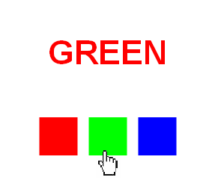

If GREEN appears you would select the green box as shown
Stroop (colour)
Click the coloured square that matches the COLOUR of the word (e.g., Participant should select the red coloured square when the word Blue OR word Red, coloured red, is displayed). The participant will have 45 seconds to complete this task.

Stroop (Colour) - Input parameters
words=RED,GREEN,BLUE
colors=0xFF0000,0x00FF00,0x0000FF
delaytime=0 as above
timelimit=45000
checkforcolor=1

Stroop (Colour) - Input parameters - PRACTICE
words=RED,GREEN,BLUE
colors=0xFF0000,0x00FF00,0x0000FF
delaytime= 0 as above
timelimit=45000
checkforcolor=1

Stroop (colour) – Participant Instructions
This task measures reaction time to colours and words.
Three different coloured squares will be displayed at the bottom of the screen.
Click on the coloured square that matches the COLOUR (red, blue or green) of the word above
See the example next
Your responses will be timed.
Accuracy is as important as speed in this task.
To begin, please click on the “Start” button.
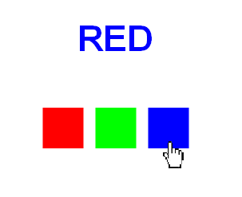

If RED appears you would select the blue box as shown

References:
Lezak, D., Neuropsychological assessment. 4th Edition. 2004: Oxford University Press.

